HAPPY BIRTHDAY
Written by The Besties: Jeremy Thoms, Felice Arena and Andy Kelly.
Featured on The Besties - The Ukulele Album (Stereogram Recordings 2019).

Chords used in the song
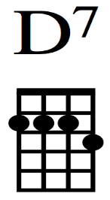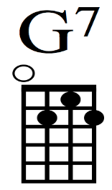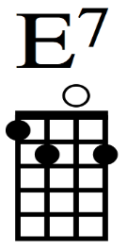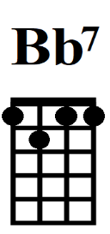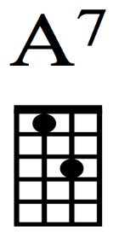

D7
Happy Birthday, you’re number one,
G7
Full of laughter, full of fun.
E7
Blow out the candles on your birthday cake.
Bb7 A7
Jump up and down and give yourself a shake.

D7
Happy Birthday, till you make a wish (tell them)
G7
Fly with the birds (tell them), swim with the fish (tell them)
E7
Let everybody know it’s your special day
Bb7 A7
Happy Happy Birthday!

D7
Happy Birthday till you tell all your friends (tell them)
G7
Let them sing and play party games (tell them)
E7
Let everybody know it’s your special day
Bb7 A7
Happy Happy Birthday

D7
Happy Birthday, you’re number one (tell them)
G7
Happy Birthday, have lots of fun (tell them)
E7
Blow out the candles one by one
Bb7 A7
Happy Birthday – Congratulations!

D7
Happy Birthday, you’re number one (tell them)
G7
Full of laughter (tell them), full of fun (tell them)
E7
Blow out the candles on your birthday cake.
Bb7 A7
Jump up and down and give yourself a shake.

D7
Happy Birthday, you’re number one (tell them)
G7
Happy Birthday (tell them), have lots of fun (tell them)
E7
Blow out the candles one by one
Bb7 A7
Happy Birthday – Congratulations!

D7
Happy Birthday!

