SUNSHINY FEELINGS
Written by The Besties: Jeremy Thoms, Felice Arena and Andy Kelly.
Featured on The Besties - The Ukulele Album (Stereogram Recordings 2019).
Chords used in the song:
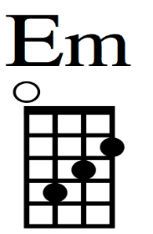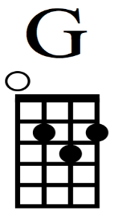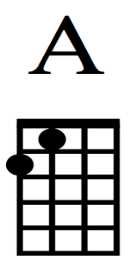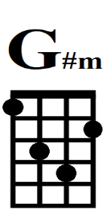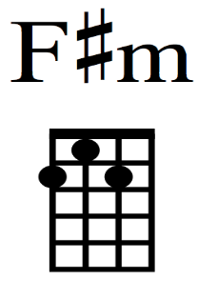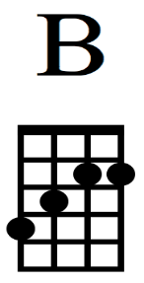
D Em G A
Sunshiny feelings are shining on me,
D Em G A
Because I’m here with you by the sea.
D Em G A
Here at the beach, there’s so much to do,
D Em G A
Like swimming and dodging all the seagulls too

D F#m G A
Diddle-lee-dooooo oo oo
D F#m G A
Diddle-lee-deeeee oo oo
D F#m G A
Diddle-lee-dooooo oo oo
D F#m G A
Diddle-lee-deeeee oo oo

D Em G A
The sun and the sand, the water and land.
D Em G A
And two of the friends and an ice-cream stand
D Em G A
The sun and the sand, the water and land
D Em G A
Because I’m so glad that I’ve got you

D F#m G A
Diddle-lee-dooooo oo oo
D F#m G A
Diddle-lee-deeeee oo oo
D F#m G A
Diddle-lee-dooooo oo oo
D F#m G A
Diddle-lee-deeeee oo oo

D Em G A
Fun beachy feelings and catching the waves
D Em G A
Rockpools, sandcastles and playing all day
D Em G A
Sunshiny feelings are shining on me,
D Em G A
Because I’m here with you by the sea.

E G#m A B
Diddle-lee-dooooo oo oo
E G#m A B
Diddle-lee-deeeee oo oo
E G#m A B
Diddle-lee-dooooo oo oo
E G#m A B
Diddle-lee-deeeee oo oo

